Shopping by Skill: A Skill Vectorization Index for NBA Draft and Roster Construction

Basketball Track
Paper ID: 171

Introduction
Every draft produces top picks who fall short of expectations and late selections who emerge as hidden gems. Prior approaches to draft prediction often reduce the problem to predicting single outcomes, such as games played, which oversimplifies success and misses the skill-by-skill contributions critical to roster building. Multi-tier predictions better reflect NBA decision-making needs but are inherently more difficult than binary outcomes such as “All-Star vs. not.”
Building on prior work such as How to Predict the Performance of NBA Draft Prospects (Turkington et al., MIT Sloan Sports Analytics Conference, 2024), which modeled outcomes using metrics like VORP and minutes played, we extend the problem by focusing on how specific skills (rebounding, shooting, playmaking, defense) translate to the NBA, representing each player as a vector of skill tiers rather than an aggregate success score.

Methods
We introduce the Skill Vectorization Index (SVI), a new multi-domain metric that projects a prospect’s aptitude in rebounding, playmaking, shooting, and defense, assigning each to one of three tiers: bottom 25% (low contribution), middle 50% (rotational contributor), or top 25% (starting caliber). By modeling success this way, franchises can draft to address specific team needs, like rebounding depth, rather than relying on blunt, one-stat metrics.
We predict SVI by training three machine learning decision tree models: Histogram-based Gradient Boosting, XGBoost, and Random Forest. To enhance predictive accuracy, we engineered features capturing efficiency and usage context, then applied clustering to group players by archetype before training the models. The models are trained on collegiate statistics of NBA players between 2009 and 2019 (n = 1,272).

Results
Simple baselines using college Win Shares and Points alone produced only 35–41% accuracy. These baselines underscore how simplistic, one-metric approaches underestimate professional outcomes, while SVI models multi-skill pathways to success. Our models achieve 65–75% accuracy across folds, outperforming baselines (Fig. A).
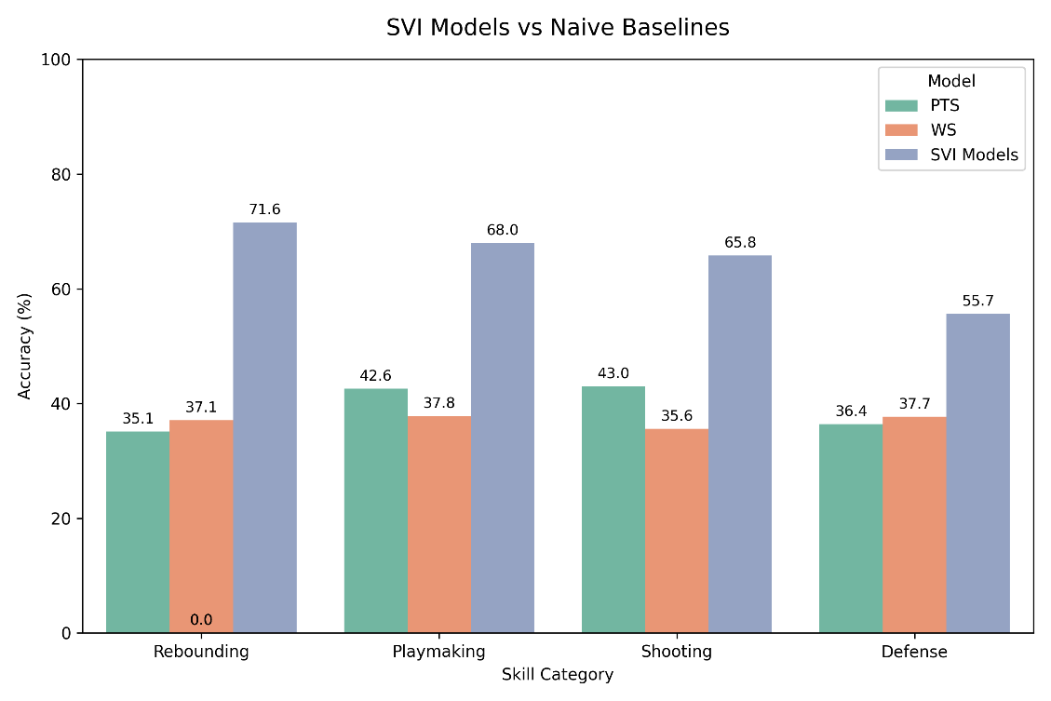

Fig. A - Side by side bar comparison of the SVI model performance compared to naïve metrics

Skill-level results reveal that rebounding tiers were the most reliably predicted, since rebounding is system-independent and tends to translate consistently across levels of play, as confirmed by statistical testing. Shooting and playmaking showed relatively moderate accuracy, as efficiency often depends on adjustments to spacing, usage, and role that shift significantly between college and the NBA. Defense proved most difficult to model, reflecting both the scarcity of detailed defensive metrics in college box scores and the heavy role of team schemes in shaping professional defensive performance. Incorporating clustered and engineered features significantly boosted predictive accuracy, with statistical tests confirming their contribution to model performance.

Conclusion
By projecting SVI tiers across rebounding, playmaking, shooting, and defense, our method shifts draft evaluation from asking “will this player make it?” to “how will this player contribute?” This provides general managers and scouting departments with a more actionable roster construction tool to keep a competitive edge while also giving fans and media a transparent view of how player skills translate to the NBA.

References
- Czasonis, M., Kritzman, M., Kulasekaran, C., & Turkington, D. (2024, March). How to predict the performance of NBA draft prospects. In 18th Annual MIT Sloan Sports Analytics Conference, Boston, MA. Paper ID: 193977.

